EESTI INFOTEHNOLOOGIA KOLLEDŽ

Dmitri Kiriljuk

INFO RIISTVARA KOHTA

Sissejuhatus infotehnoloogiasse ja riistvarasse

Praktiline töö

INFOTEHNOLOOGIA SÜSTEEMIDE ADMINISTREERIMISE ÕPPEKAVA

Õppejõud: Edmund Laugasson

Tallinn 2017

# Praktiline töö laboris 4.03.2017

Serveri parametrid:

* IBM X-Series 346
* Serveri S/N KDWYM13
* Ubuntu 16.04 (Unity desktop environment)

Harjutus:

* panna masinat käima ja teha puhtaks
* luua alglaaditav mälupulk GNU/Linuxiga
* Linuxit paigaldada

Alglaaditava mälupulga tegemiseks kasutasime *rufus* tarkvarat.

1. 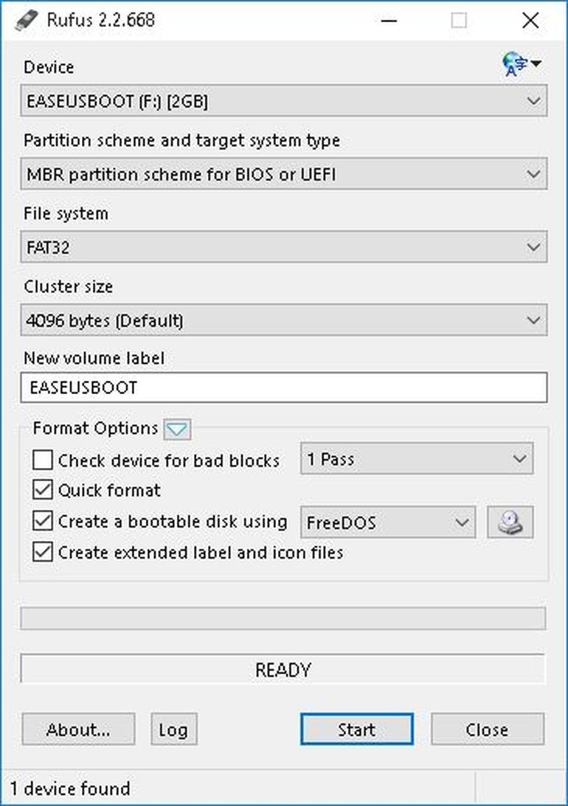Sisestage USB mälupulk ja käivitada Rufus. See avastada sõita peaaegu kohe. Kuna Rufus saavad hakkama erinevate partitsiooni skeemid ja struktuurid, et tagada õige seaded on määratud, mis vastavad UFD sa lähed ehitada (joonis A).

Joonis A

1. 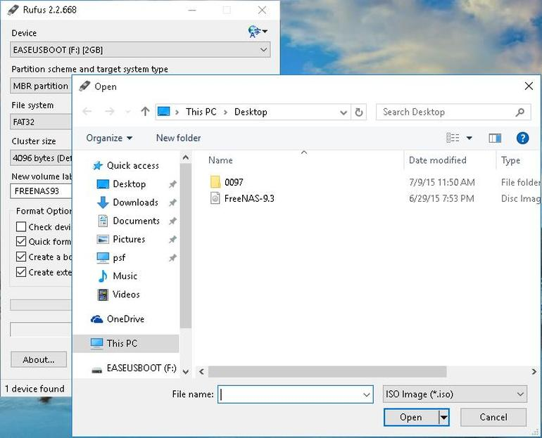Klõpsake optiline seade nuppu Loo alglaadimisketta kasutades ära ning siis palutakse otsida ISO image kasutada (Joonis B).

Joonis B

1. 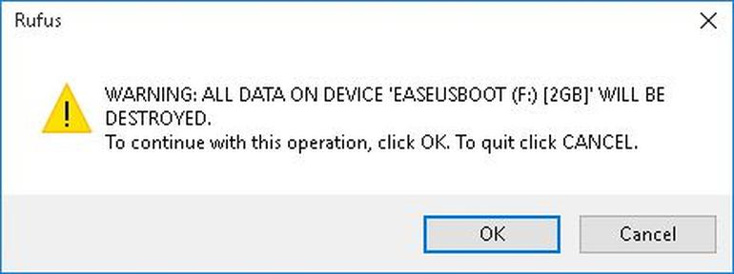When using ISO images, Rufus will automatically modify the settings to best match it. Once everything is set correctly, click the Start button to begin the process. You'll be prompted with a warning that all data on the UFD will be destroyed. Click OK to proceed with the creation process (**Figure C**).

Joonis C

1. 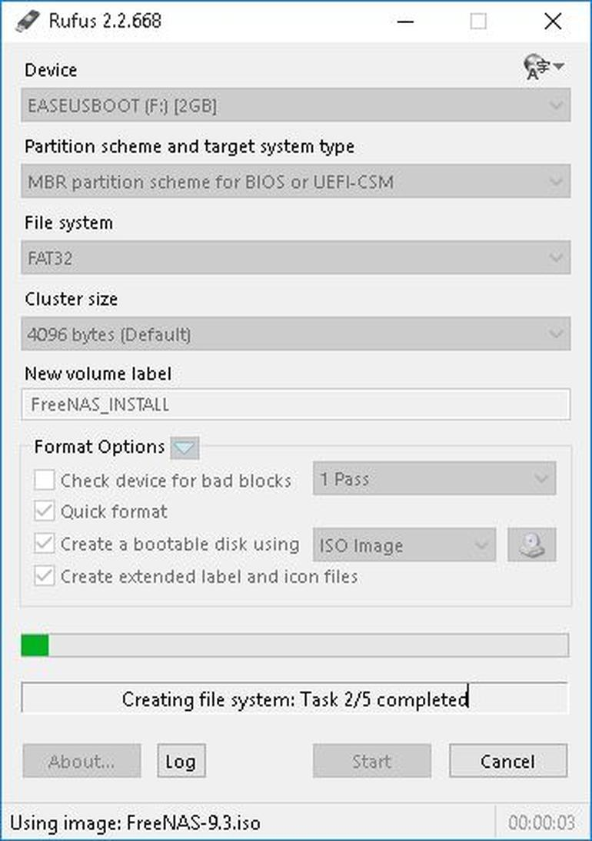Sõltuvalt ISO pildi suurus, protsess võib kesta mitu minutit. Sest samamoodi näit iga samm, kliki log avab küljeakna ja väljund salvestada üksikasjad (Joonis D).

Joonis D

1. Pikim osa kogu protsess on arhiivieksemplar osa. See on tavaliselt viimane samm ning oleneb faili suurus / hulk faile kopeerida (Joonis E).  
   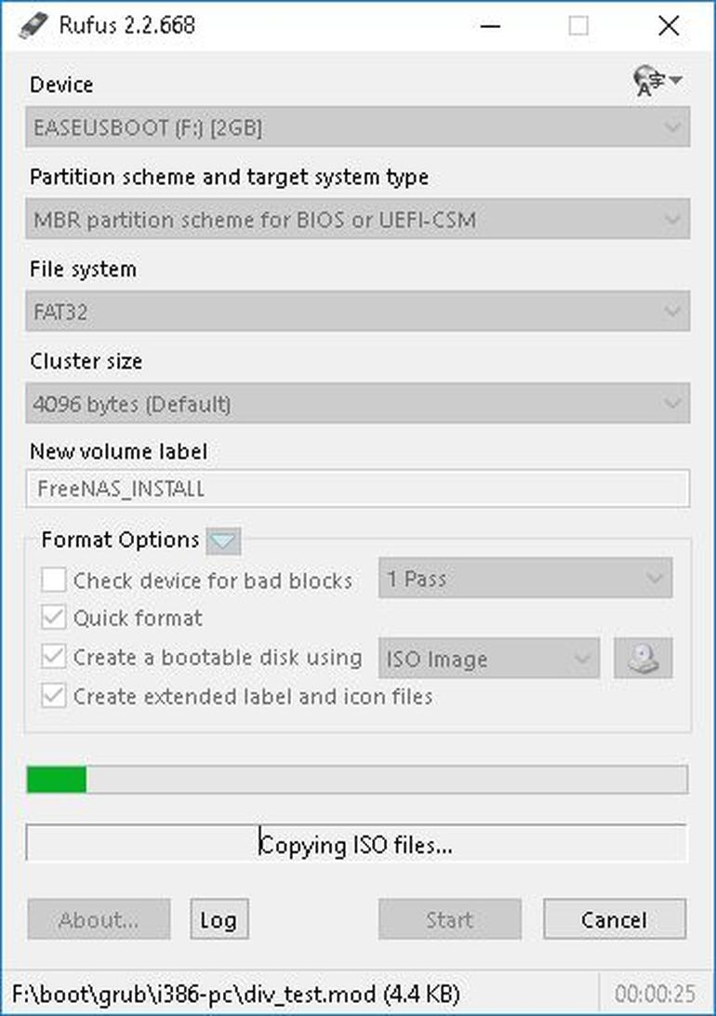

Joonis E

OP süsteemi paigaldmine (Ubuntu 16.04 LTS):

1. Tervitusekraan

Enamik uuemaid arvuteid saab buutida USB. Sa peaksid nägema tervitusekraanile märku, et valida oma keel ning annab teile võimaluse paigaldada Ubuntu või proovima USB.( Joonis F)

[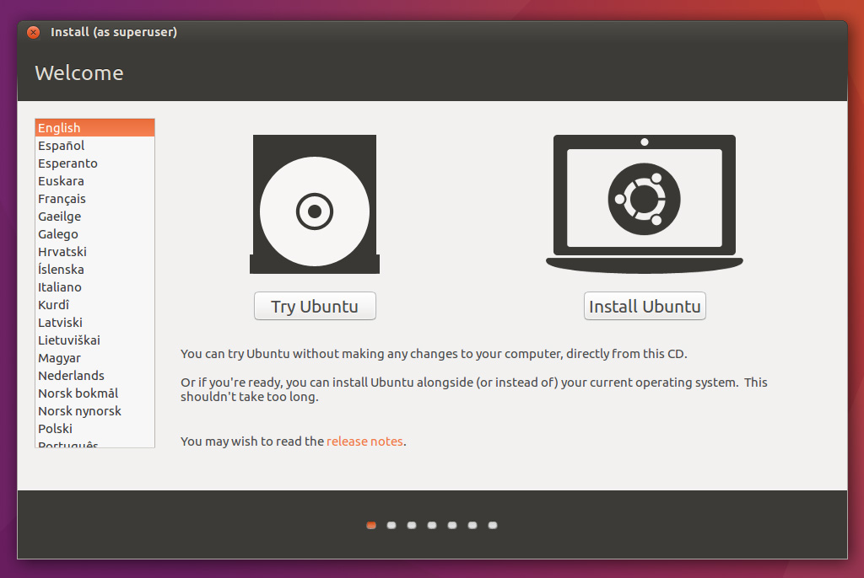](https://assets.ubuntu.com/v1/dfc572f0-download-desktop-install-ubuntu-desktop_1.jpg)

Joonis F

1. [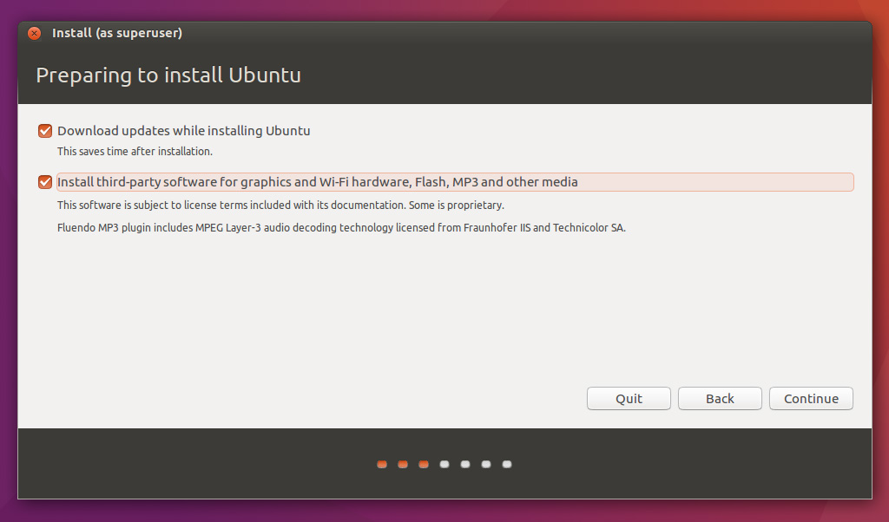](https://assets.ubuntu.com/v1/3bbb0e35-download-desktop-install-ubuntu-desktop_2.jpg)Valmista paigaldada Ubuntu (Joonis G)

Joonis G

1. Eraldada kettaruumi

[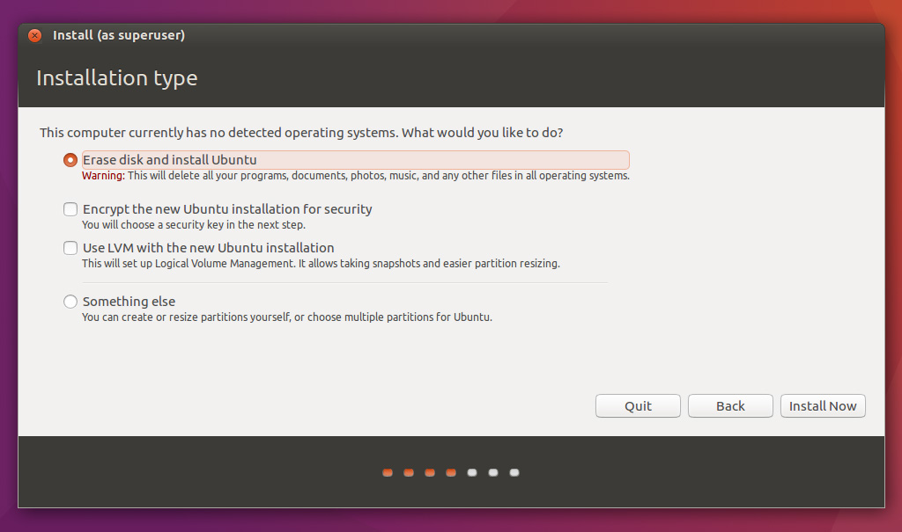](https://assets.ubuntu.com/v1/b42312cd-download-desktop-install-ubuntu-desktop_4.jpg)Valida, kas soovite installida Ubuntu kõrval teise operatsioonisüsteemi, kustutada oma olemasoleva operatsioonisüsteemi ja asendada see Ubuntu või - kui sa oled kogenud kasutaja - vali „Something else“(Joonis H)

Joonis H

1. Alusta paigaldamist

Sõltuvalt oma eelmise valikud, mida saab nüüd kontrollida, et olete valinud viisi soovid paigaldada Ubuntu. Paigaldamise protsess algab, kui klõpsate nupul Installi nüüd.

[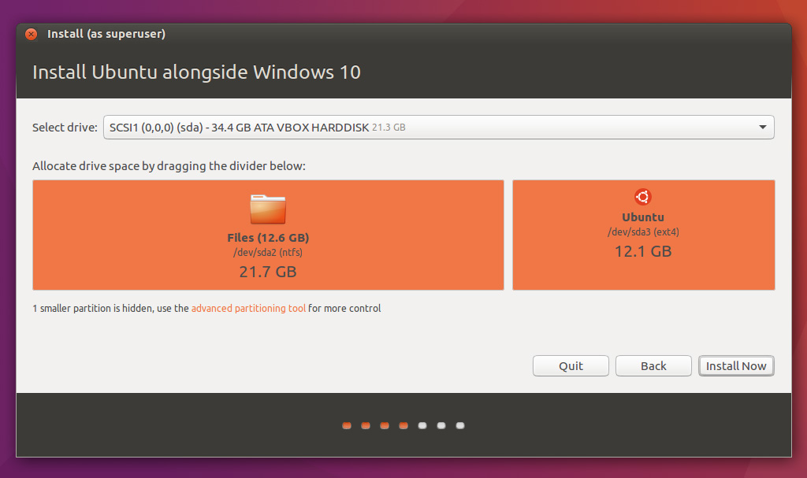](https://assets.ubuntu.com/v1/6d01bd8c-download-desktop-install-ubuntu-desktop_5.jpg)Ubuntu vajab umbes 4,5 GB paigaldada nii, lisada paar ekstra GB võimaldada oma faile.(Joonis I)

Joonis I

1. Valige oma asukoht

Kui olete ühendatud internetti, tuleks seda teha automaatselt. Kontrolli oma asukohta on õige ja klõpsa "Edasi" edasi minna. Kui te kahtlete oma ajatsooni, tippige linna nime sa sisse või klõpsa kaardil ja me aitame teil leida.

[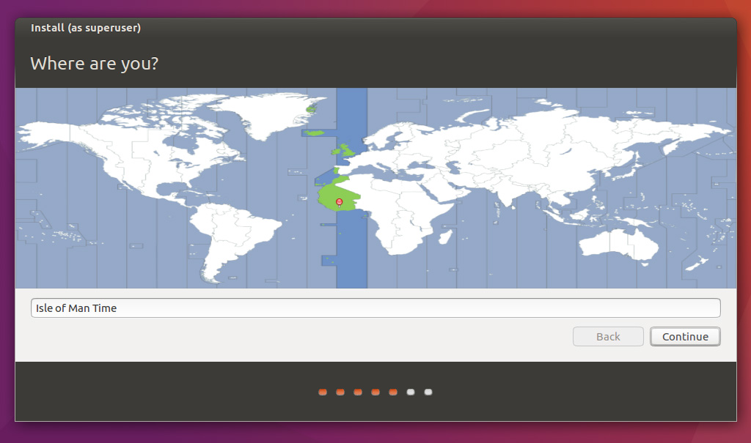](https://assets.ubuntu.com/v1/a942aa3d-download-desktop-install-ubuntu-desktop_6.jpg)TIP: Kui sul on probleeme internetiga ühendatud, kasutage menüü ülemises paremas nurgas 6. Valige oma eelistatud klahvipaigutust

Joonis J

1. Valige oma eelistatud klahvipaigutust

[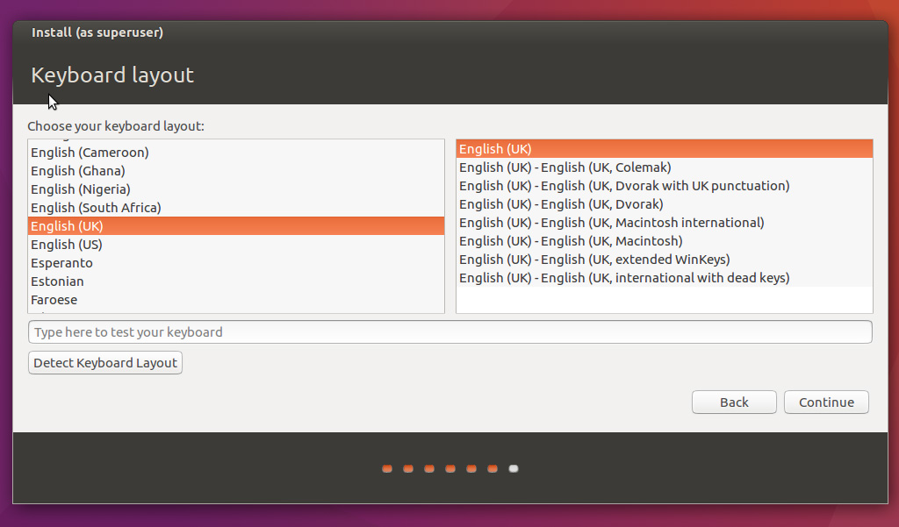](https://assets.ubuntu.com/v1/310b5196-download-desktop-install-ubuntu-desktop_7.jpg)Vajuta keele variant, mida vaja. Kui sa ei ole kindel, klõpsake "Detect Klaviatuuripaigutus" nupp aidata. (Joonis K)

Joonis K

1. [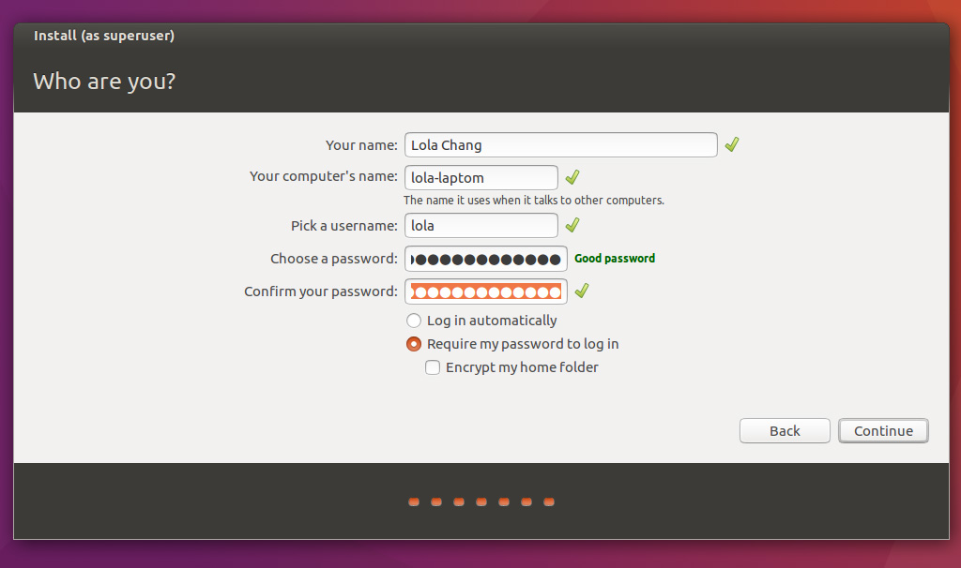](https://assets.ubuntu.com/v1/69d32ea7-download-desktop-install-ubuntu-desktop_8.jpg)Sisesta oma kasutajanime ja parooli (Joonis L)

Joonis L

1. Ubuntu installeerimine (Joonis M)[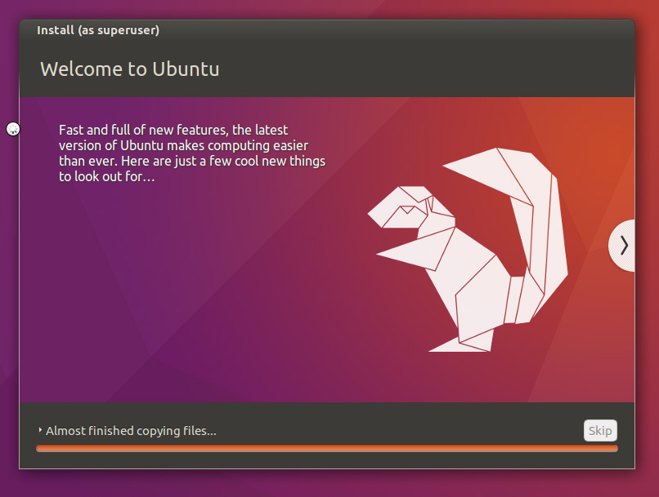](https://assets.ubuntu.com/v1/4e133117-download-desktop-install-ubuntu-desktop_9.jpg)

Joonis M

1. Nii see on.

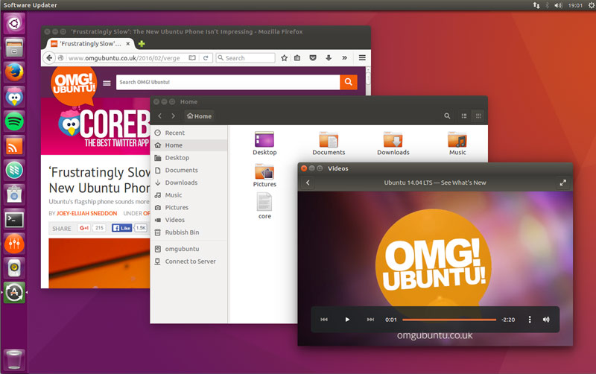

Joonis N

IBM Serveri riistvara tuvastamiseks läbi Linuxi terminali:

1. lsb_release -a (printimine jaotus info)
   * No LSB modules are available.
   * Distributor ID: Ubuntu
   * Description: Ubuntu Xenial Xerus (development branch)
   * Release: 16.04
   * Codename: xenial
2. uname -sr (tuuma kindlakstegemiseks)

* Linux 4.8.0-22-generic

1. inxi -r kasutatavate varamute tuvastamiseks (serverid tarkvara turvaliseks hoidmiseks)
   * Repos: Active apt sources in file: /etc/apt/sources.list **(See on resopositeries, milised Linux kasutab updati jaoks või tarkvara intalerimise jaoks)**
   * deb http://us.archive.ubuntu.com/ubuntu/ yakkety main restricted
   * deb http://us.archive.ubuntu.com/ubuntu/ yakkety-updates main restricted
   * deb http://us.archive.ubuntu.com/ubuntu/ yakkety universe
   * deb http://us.archive.ubuntu.com/ubuntu/ yakkety-updates universe
   * deb http://us.archive.ubuntu.com/ubuntu/ yakkety multiverse
   * deb http://us.archive.ubuntu.com/ubuntu/ yakkety-updates multiverse
   * deb http://us.archive.ubuntu.com/ubuntu/ yakkety-backports main restricted universe multiverse
   * deb http://security.ubuntu.com/ubuntu yakkety-security main restricted
   * deb http://security.ubuntu.com/ubuntu yakkety-security universe
   * deb http://security.ubuntu.com/ubuntu yakkety-security multiverse
2. inxi -xxM inxi -xxxS (emaplaadi, süsteemiinfo tuvastamiseks)
   * Machine: System: IBM product: eserver xSeries 346 -[8840EAY]- serial: KDWYM13 Chassis: type: 17 **(See on masina toote info)**
   * Mobo: IBM model: N/A BIOS: IBM v: -[KPE144AUS-1.17]- date: 09/11/2007 **(toota kuupäev)**
3. cat /proc/cpuinfo (protsessori info)
   * processor : 0 **(protsessorite arv)**
   * vendor_id : GenuineIntel **(müüja)**
   * cpu family : 15 **(protsessori sugupõlv)**
   * model : 4 **(muudel)**
   * model name : Intel(R) Xeon(TM) CPU 3.00GHz **(muudeli nimi)**
   * stepping : 3 **(versiooni number töötleja või kiibistiku arhitektuur)**
   * microcode : 0x4
   * cpu MHz : 3000.072 **(protsessori kiirust)**
   * cache size : 2048 KB **(Protsessori vahemälu (inglise k. CPU cache) on mälu, mida arvuti protsessor kasutab põhimällu pöördumisele keskmiselt kuluva aja lühendamiseks.)**
   * physical id : 0
   * siblings : 2 **(Kui mitu siblings on võrdne arv südamikud siis on protsessoriga, mis ei ole HyperThreading või Hyperthreading on välja lülitatud, kui number siblings on 2x arvu südamikud siis on Hyperthreading CPU Hyperthreading sisse lülitatud.)**
   * core id : 0
   * cpu cores : 1**(tuma number)**
   * apicid : 0
   * initial apicid : 0
   * fpu : yes
   * fpu_exception : yes
   * cpuid level : 5
   * wp : yes
   * flags : fpu vme de pse tsc msr pae mce cx8 apic sep mtrr pge mca cmov pat pse36 clflush dts acpi mmx fxsr sse sse2 ss ht tm pbe syscall nx lm constant_tsc pebs bts nopl eagerfpu pni dtes64 monitor ds_cpl cid cx16 xtpr
   * bugs :
   * bogomips : 6000.14
   * clflush size : 64
   * cache_alignment : 128
   * address sizes : 36 bits physical, 48 bits virtual
   * power management:
   * processor : 1
   * vendor_id : GenuineIntel
   * cpu family : 15
   * model : 4
   * model name : Intel(R) Xeon(TM) CPU 3.00GHz
   * stepping : 3
   * microcode : 0x4
   * cpu MHz : 3000.072
   * cache size : 2048 KB
   * physical id : 3
   * siblings : 2
   * core id : 0
   * cpu cores : 1
   * apicid : 6
   * initial apicid : 6
   * fpu : yes
   * fpu_exception : yes
   * cpuid level : 5
   * wp : yes
   * flags : fpu vme de pse tsc msr pae mce cx8 apic sep mtrr pge mca cmov pat pse36 clflush dts acpi mmx fxsr sse sse2 ss ht tm pbe syscall nx lm constant_tsc pebs bts nopl eagerfpu pni dtes64 monitor ds_cpl cid cx16 xtpr
   * bugs :
   * bogomips : 6000.14
   * clflush size : 64
   * cache_alignment : 128
   * address sizes : 36 bits physical, 48 bits virtual
   * power management:
   * processor : 2
   * vendor_id : GenuineIntel
   * cpu family : 15
   * model : 4
   * model name : Intel(R) Xeon(TM) CPU 3.00GHz
   * stepping : 3
   * microcode : 0x4
   * cpu MHz : 3000.072
   * cache size : 2048 KB
   * physical id : 0
   * siblings : 2
   * core id : 0
   * cpu cores : 1
   * apicid : 1
   * initial apicid : 1
   * fpu : yes
   * fpu_exception : yes
   * cpuid level : 5
   * wp : yes
   * flags : fpu vme de pse tsc msr pae mce cx8 apic sep mtrr pge mca cmov pat pse36 clflush dts acpi mmx fxsr sse sse2 ss ht tm pbe syscall nx lm constant_tsc pebs bts nopl eagerfpu pni dtes64 monitor ds_cpl cid cx16 xtpr
   * bugs :
   * bogomips : 6000.14
   * clflush size : 64
   * cache_alignment : 128
   * address sizes : 36 bits physical, 48 bits virtual
   * power management:
   * processor : 3
   * vendor_id : GenuineIntel
   * cpu family : 15
   * model : 4
   * model name : Intel(R) Xeon(TM) CPU 3.00GHz
   * stepping : 3
   * microcode : 0x4
   * cpu MHz : 3000.072
   * cache size : 2048 KB
   * physical id : 3
   * siblings : 2
   * core id : 0
   * cpu cores : 1
   * apicid : 7
   * initial apicid : 7
   * fpu : yes
   * fpu_exception : yes
   * cpuid level : 5
   * wp : yes
   * flags : fpu vme de pse tsc msr pae mce cx8 apic sep mtrr pge mca cmov pat pse36 clflush dts acpi mmx fxsr sse sse2 ss ht tm pbe syscall nx lm constant_tsc pebs bts nopl eagerfpu pni dtes64 monitor ds_cpl cid cx16 xtpr
   * bugs :
   * bogomips : 6000.14
   * clflush size : 64
   * cache_alignment : 128
   * address sizes : 36 bits physical, 48 bits virtual
   * power management:
4. inxi -t c (protsessori-, mälukasutuse tuvastamiseks.)

* Processes: CPU: % used - top 5 active
* 1: cpu: 0.8% command: init pid: 1
* 2: cpu: 0.3% daemon: ~kworker/1:0~ pid: 3701
* 3: cpu: 0.2% command: dbus-daemon pid: 1934 **(Näiteks siin on näha kui palju protesori koormuse kasutab dbus-demon)**
* 4: cpu: 0.1% daemon: ~kworker/1:208~ pid: 1339
* 5: cpu: 0.0% daemon: ~kworker/3:0~ pid: 5027

1. cat /proc/meminfo ()
   * MemTotal: 4045608 kB
   * MemFree: 3331120 kB
   * MemAvailable: 3692040 kB
   * Buffers: 26672 kB
   * Cached: 524596 kB
   * SwapCached: 0 kB
   * Active: 266948 kB
   * Inactive: 318120 kB
   * Active(anon): 36764 kB
   * Inactive(anon): 5408 kB
   * Active(file): 230184 kB
   * Inactive(file): 312712 kB
   * Unevictable: 3648 kB
   * Mlocked: 3648 kB
   * SwapTotal: 4194300 kB
   * SwapFree: 4194300 kB
   * Dirty: 48 kB
   * Writeback: 0 kB
   * AnonPages: 36900 kB
   * Mapped: 31636 kB
   * Shmem: 5956 kB
   * Slab: 82084 kB
   * SReclaimable: 43316 kB
   * SUnreclaim: 38768 kB
   * KernelStack: 2880 kB
   * PageTables: 3892 kB
   * NFS_Unstable: 0 kB
   * Bounce: 0 kB
   * WritebackTmp: 0 kB
   * CommitLimit: 6217104 kB
   * Committed_AS: 245948 kB
   * VmallocTotal: 34359738367 kB
   * VmallocUsed: 0 kB
   * VmallocChunk: 0 kB
   * HardwareCorrupted: 0 kB
   * AnonHugePages: 0 kB
   * ShmemHugePages: 0 kB
   * ShmemPmdMapped: 0 kB
   * CmaTotal: 0 kB
   * CmaFree: 0 kB
   * HugePages_Total: 0
   * HugePages_Free: 0
   * HugePages_Rsvd: 0
   * HugePages_Surp: 0
   * Hugepagesize: 2048 kB
   * DirectMap4k: 73520 kB
   * DirectMap2M: 4120576 kB
2. Lsusb (seadmete tuvastamiseks)

* Bus 001 Device 001: ID 1d6b:0002 Linux Foundation 2.0 root hub
* Bus 003 Device 002: ID 04b3:4001 IBM Corp.
* Bus 003 Device 001: ID 1d6b:0001 Linux Foundation 1.1 root hub
* Bus 002 Device 001: ID 1d6b:0001 Linux Foundation 1.1 root hub

1. fdisk -l

* Disk /dev/ram0: 64 MiB, 67108864 bytes, 131072 sectors
* Units: sectors of 1 * 512 = 512 bytes
* Sector size (logical/physical): 512 bytes / 4096 bytes
* I/O size (minimum/optimal): 4096 bytes / 4096 bytes
* Disk /dev/ram1: 64 MiB, 67108864 bytes, 131072 sectors
* Units: sectors of 1 * 512 = 512 bytes
* Sector size (logical/physical): 512 bytes / 4096 bytes
* I/O size (minimum/optimal): 4096 bytes / 4096 bytes
* Disk /dev/ram2: 64 MiB, 67108864 bytes, 131072 sectors
* Units: sectors of 1 * 512 = 512 bytes
* Sector size (logical/physical): 512 bytes / 4096 bytes
* I/O size (minimum/optimal): 4096 bytes / 4096 bytes
* Disk /dev/ram3: 64 MiB, 67108864 bytes, 131072 sectors
* Units: sectors of 1 * 512 = 512 bytes
* Sector size (logical/physical): 512 bytes / 4096 bytes
* I/O size (minimum/optimal): 4096 bytes / 4096 bytes
* Disk /dev/ram4: 64 MiB, 67108864 bytes, 131072 sectors
* Units: sectors of 1 * 512 = 512 bytes
* Sector size (logical/physical): 512 bytes / 4096 bytes
* I/O size (minimum/optimal): 4096 bytes / 4096 bytes
* Disk /dev/ram5: 64 MiB, 67108864 bytes, 131072 sectors
* Units: sectors of 1 * 512 = 512 bytes
* Sector size (logical/physical): 512 bytes / 4096 bytes
* I/O size (minimum/optimal): 4096 bytes / 4096 bytes
* Disk /dev/ram6: 64 MiB, 67108864 bytes, 131072 sectors
* Units: sectors of 1 * 512 = 512 bytes
* Sector size (logical/physical): 512 bytes / 4096 bytes
* I/O size (minimum/optimal): 4096 bytes / 4096 bytes
* Disk /dev/ram7: 64 MiB, 67108864 bytes, 131072 sectors
* Units: sectors of 1 * 512 = 512 bytes
* Sector size (logical/physical): 512 bytes / 4096 bytes
* I/O size (minimum/optimal): 4096 bytes / 4096 bytes
* Disk /dev/ram8: 64 MiB, 67108864 bytes, 131072 sectors
* Units: sectors of 1 * 512 = 512 bytes
* Sector size (logical/physical): 512 bytes / 4096 bytes
* I/O size (minimum/optimal): 4096 bytes / 4096 bytes
* Disk /dev/ram9: 64 MiB, 67108864 bytes, 131072 sectors
* Units: sectors of 1 * 512 = 512 bytes
* Sector size (logical/physical): 512 bytes / 4096 bytes
* I/O size (minimum/optimal): 4096 bytes / 4096 bytes
* Disk /dev/ram10: 64 MiB, 67108864 bytes, 131072 sectors
* Units: sectors of 1 * 512 = 512 bytes
* Sector size (logical/physical): 512 bytes / 4096 bytes
* I/O size (minimum/optimal): 4096 bytes / 4096 bytes
* Disk /dev/ram11: 64 MiB, 67108864 bytes, 131072 sectors
* Units: sectors of 1 * 512 = 512 bytes
* Sector size (logical/physical): 512 bytes / 4096 bytes
* I/O size (minimum/optimal): 4096 bytes / 4096 bytes
* Disk /dev/ram12: 64 MiB, 67108864 bytes, 131072 sectors
* Units: sectors of 1 * 512 = 512 bytes
* Sector size (logical/physical): 512 bytes / 4096 bytes
* I/O size (minimum/optimal): 4096 bytes / 4096 bytes
* Disk /dev/ram13: 64 MiB, 67108864 bytes, 131072 sectors
* Units: sectors of 1 * 512 = 512 bytes
* Sector size (logical/physical): 512 bytes / 4096 bytes
* I/O size (minimum/optimal): 4096 bytes / 4096 bytes
* Disk /dev/ram14: 64 MiB, 67108864 bytes, 131072 sectors
* Units: sectors of 1 * 512 = 512 bytes
* Sector size (logical/physical): 512 bytes / 4096 bytes
* I/O size (minimum/optimal): 4096 bytes / 4096 bytes
* Disk /dev/ram15: 64 MiB, 67108864 bytes, 131072 sectors
* Units: sectors of 1 * 512 = 512 bytes
* Sector size (logical/physical): 512 bytes / 4096 bytes
* I/O size (minimum/optimal): 4096 bytes / 4096 bytes
* Disk /dev/sda: 68.4 GiB, 73407488000 bytes, 143374000 sectors
* Units: sectors of 1 * 512 = 512 bytes
* Sector size (logical/physical): 512 bytes / 512 bytes
* I/O size (minimum/optimal): 512 bytes / 512 bytes
* Disklabel type: dos
* Disk identifier: 0x2725d476
* Device Boot Start End Sectors Size Id Type
* /dev/sda1 * 2048 999423 997376 487M 83 Linux
* /dev/sda2 1001470 143372287 142370818 67.9G 5 Extended
* /dev/sda5 1001472 143372287 142370816 67.9G 8e Linux LVM
* Disk /dev/sdb: 68.4 GiB, 73407488000 bytes, 143374000 sectors
* Units: sectors of 1 * 512 = 512 bytes
* Sector size (logical/physical): 512 bytes / 512 bytes
* I/O size (minimum/optimal): 512 bytes / 512 bytes
* Disk /dev/mapper/serv--vg-root: 63.9 GiB, 68597841920 bytes, 133980160 sectors
* Units: sectors of 1 * 512 = 512 bytes
* Sector size (logical/physical): 512 bytes / 512 bytes
* I/O size (minimum/optimal): 512 bytes / 512 bytes
* Disk /dev/mapper/serv--vg-swap_1: 4 GiB, 4294967296 bytes, 8388608 sectors
* Units: sectors of 1 * 512 = 512 bytes
* Sector size (logical/physical): 512 bytes / 512 bytes
* I/O size (minimum/optimal): 512 bytes / 512 bytes

1. dmidecode

* # dmidecode 3.0
* Getting SMBIOS data from sysfs.
* SMBIOS 2.3 present.
* 55 structures occupying 2343 bytes.
* Table at 0x000F8779.
* Handle 0x0000, DMI type 0, 19 bytes
* BIOS Information
* Vendor: IBM
* Version: -[KPE144AUS-1.17]-
* Release Date: 09/11/2007
* Address: 0xF0E90
* Runtime Size: 61808 bytes
* ROM Size: 4096 kB
* Characteristics:
* PCI is supported
* BIOS is upgradeable
* BIOS shadowing is allowed
* Boot from CD is supported
* Selectable boot is supported
* Japanese floppy for NEC 9800 1.2 MB is supported (int 13h)
* Japanese floppy for Toshiba 1.2 MB is supported (int 13h)
* 5.25"/360 kB floppy services are supported (int 13h)
* 5.25"/1.2 MB floppy services are supported (int 13h)
* 3.5"/720 kB floppy services are supported (int 13h)
* 3.5"/2.88 MB floppy services are supported (int 13h)
* Print screen service is supported (int 5h)
* 8042 keyboard services are supported (int 9h)
* Serial services are supported (int 14h)
* Printer services are supported (int 17h)
* CGA/mono video services are supported (int 10h)
* ACPI is supported
* USB legacy is supported
* I2O boot is supported
* LS-120 boot is supported
* Handle 0x0001, DMI type 1, 25 bytes
* System Information
* Manufacturer: IBM
* Product Name: eserver xSeries 346 -[8840EAY]-
* Version: Not Specified
* Serial Number: KDWYM13
* UUID: 8E3264C6-1606-336E-8A50-EDF65D4F37F3
* Wake-up Type: Power Switch
* Handle 0x0002, DMI type 2, 8 bytes
* Base Board Information
* Manufacturer: IBM
* Product Name: Not Specified
* Version: Not Specified
* Serial Number: Not Specified
* Handle 0x0003, DMI type 3, 13 bytes
* Chassis Information
* Manufacturer: IBM
* Type: Main Server Chassis
* Lock: Not Present
* Version: Not Specified
* Serial Number: Not Specified
* Asset Tag:
* Boot-up State: Safe
* Power Supply State: Unknown
* Thermal State: Unknown
* Security Status: Unknown
* Handle 0x0004, DMI type 7, 19 bytes
* Cache Information
* Socket Designation: Internal L1 Cache
* Configuration: Enabled, Not Socketed, Level 1
* Operational Mode: Write Back
* Location: Internal
* Installed Size: 16 kB
* Maximum Size: 16 kB
* Supported SRAM Types:
* Synchronous
* Installed SRAM Type: Synchronous
* Speed: Unknown
* Error Correction Type: Unknown
* System Type: Unified
* Associativity: 4-way Set-associative
* Handle 0x0005, DMI type 7, 19 bytes
* Cache Information
* Socket Designation: Internal L2 Cache
* Configuration: Enabled, Not Socketed, Level 2
* Operational Mode: Write Back
* Location: Internal
* Installed Size: 2048 kB
* Maximum Size: 2048 kB
* Supported SRAM Types:
* Burst
* Installed SRAM Type: Burst
* Speed: Unknown
* Error Correction Type: Unknown
* System Type: Unified
* Associativity: 8-way Set-associative
* Handle 0x0006, DMI type 7, 19 bytes
* Cache Information
* Socket Designation: Internal L1 Cache
* Configuration: Enabled, Not Socketed, Level 1
* Operational Mode: Write Back
* Location: Internal
* Installed Size: 16 kB
* Maximum Size: 16 kB
* Supported SRAM Types:
* Synchronous
* Installed SRAM Type: Synchronous
* Speed: Unknown
* Error Correction Type: Unknown
* System Type: Unified
* Associativity: 4-way Set-associative
* Handle 0x0007, DMI type 7, 19 bytes
* Cache Information
* Socket Designation: Internal L2 Cache
* Configuration: Enabled, Not Socketed, Level 2
* Operational Mode: Write Back
* Location: Internal
* Installed Size: 2048 kB
* Maximum Size: 2048 kB
* Supported SRAM Types:
* Burst
* Installed SRAM Type: Burst
* Speed: Unknown
* Error Correction Type: Unknown
* System Type: Unified
* Associativity: 8-way Set-associative
* Handle 0x000C, DMI type 4, 32 bytes
* Processor Information
* Socket Designation: Socket 1 CPU 1
* Type: Central Processor
* Family: Xeon
* Manufacturer: GenuineIntel
* ID: 43 0F 00 00 01 03 00 00
* Signature: Type 0, Family 15, Model 4, Stepping 3
* Flags:
* FPU (Floating-point unit on-chip)
* CX8 (CMPXCHG8 instruction supported)
* APIC (On-chip APIC hardware supported)
* Version: Intel Xeon
* Voltage: 1.5 V
* External Clock: 200 MHz
* Max Speed: 4000 MHz
* Current Speed: 3000 MHz
* Status: Populated, Enabled
* Upgrade: ZIF Socket
* L1 Cache Handle: 0x0004
* L2 Cache Handle: 0x0005
* L3 Cache Handle: Not Provided
* Handle 0x000D, DMI type 4, 32 bytes
* Processor Information
* Socket Designation: Socket 2 CPU 2
* Type: Central Processor
* Family: Xeon
* Manufacturer: GenuineIntel
* ID: 43 0F 00 00 01 03 00 00
* Signature: Type 0, Family 15, Model 4, Stepping 3
* Flags:
* FPU (Floating-point unit on-chip)
* CX8 (CMPXCHG8 instruction supported)
* APIC (On-chip APIC hardware supported)
* Version: Intel Xeon
* Voltage: 1.5 V
* External Clock: 200 MHz
* Max Speed: 4000 MHz
* Current Speed: 3000 MHz
* Status: Populated, Enabled
* Upgrade: ZIF Socket
* L1 Cache Handle: 0x0006
* L2 Cache Handle: 0x0007
* L3 Cache Handle: Not Provided
* Handle 0x000E, DMI type 8, 9 bytes
* Port Connector Information
* Internal Reference Designator: Not Specified
* Internal Connector Type: None
* External Reference Designator: USB 1
* External Connector Type: Access Bus (USB)
* Port Type: USB
* Handle 0x000F, DMI type 8, 9 bytes
* Port Connector Information
* Internal Reference Designator: Not Specified
* Internal Connector Type: None
* External Reference Designator: USB 2
* External Connector Type: Access Bus (USB)
* Port Type: USB
* Handle 0x0010, DMI type 8, 9 bytes
* Port Connector Information
* Internal Reference Designator: Not Specified
* Internal Connector Type: None
* External Reference Designator: USB 3
* External Connector Type: Access Bus (USB)
* Port Type: USB
* Handle 0x0011, DMI type 8, 9 bytes
* Port Connector Information
* Internal Reference Designator: IDE
* Internal Connector Type: Other
* External Reference Designator: Not Specified
* External Connector Type: None
* Port Type: Other
* Handle 0x0012, DMI type 8, 9 bytes
* Port Connector Information
* Internal Reference Designator: Not Specified
* Internal Connector Type: None
* External Reference Designator: Mouse
* External Connector Type: Mini DIN
* Port Type: Mouse Port
* Handle 0x0013, DMI type 8, 9 bytes
* Port Connector Information
* Internal Reference Designator: Not Specified
* Internal Connector Type: None
* External Reference Designator: Keyboard
* External Connector Type: Mini DIN
* Port Type: Keyboard Port
* Handle 0x0014, DMI type 8, 9 bytes
* Port Connector Information
* Internal Reference Designator: Not Specified
* Internal Connector Type: None
* External Reference Designator: Video
* External Connector Type: DB-15 female
* Port Type: Video Port
* Handle 0x0015, DMI type 8, 9 bytes
* Port Connector Information
* Internal Reference Designator: Not Specified
* Internal Connector Type: None
* External Reference Designator: Serial-A
* External Connector Type: DB-9 male
* Port Type: Serial Port 16550A Compatible
* Handle 0x0016, DMI type 8, 9 bytes
* Port Connector Information
* Internal Reference Designator: Diskette
* Internal Connector Type: Other
* External Reference Designator: Not Specified
* External Connector Type: None
* Port Type: Other
* Handle 0x0017, DMI type 8, 9 bytes
* Port Connector Information
* Internal Reference Designator: External SCSI (Channel A)
* Internal Connector Type: 68 Pin Dual Inline
* External Reference Designator: Not Specified
* External Connector Type: None
* Port Type: SCSI Wide
* Handle 0x0018, DMI type 8, 9 bytes
* Port Connector Information
* Internal Reference Designator: Internal SCSI (Channel B)
* Internal Connector Type: 68 Pin Dual Inline
* External Reference Designator: Not Specified
* External Connector Type: None
* Port Type: SCSI Wide
* Handle 0x0019, DMI type 8, 9 bytes
* Port Connector Information
* Internal Reference Designator: Not Specified
* Internal Connector Type: None
* External Reference Designator: Gigabit Ethernet 1
* External Connector Type: RJ-45
* Port Type: Network Port
* Handle 0x001A, DMI type 8, 9 bytes
* Port Connector Information
* Internal Reference Designator: Not Specified
* Internal Connector Type: None
* External Reference Designator: Gigabit Ethernet 2
* External Connector Type: RJ-45
* Port Type: Network Port
* Handle 0x001B, DMI type 9, 13 bytes
* System Slot Information
* Designation: PCI Slot 1
* Type: 64-bit PCI-X
* Current Usage: Available
* Length: Long
* ID: 1
* Characteristics:
* 3.3 V is provided
* PME signal is supported
* Handle 0x001C, DMI type 9, 13 bytes
* System Slot Information
* Designation: PCI Slot 2
* Type: 64-bit PCI-X
* Current Usage: Available
* Length: Long
* ID: 2
* Characteristics:
* 3.3 V is provided
* PME signal is supported
* Handle 0x001D, DMI type 9, 13 bytes
* System Slot Information
* Designation: PCI Slot 3
* Type: 64-bit PCI-X
* Current Usage: Available
* Length: Long
* ID: 3
* Characteristics:
* 3.3 V is provided
* PME signal is supported
* Handle 0x001E, DMI type 9, 13 bytes
* System Slot Information
* Designation: PCI Slot 4
* Type: 64-bit PCI-X
* Current Usage: Available
* Length: Long
* ID: 4
* Characteristics:
* 3.3 V is provided
* PME signal is supported
* Handle 0x001F, DMI type 10, 14 bytes
* On Board Device 1 Information
* Type: Video
* Status: Enabled
* Description: ATI Radeon 7000-M
* On Board Device 2 Information
* Type: SCSI Controller
* Status: Enabled
* Description: Adaptec 7902W SCSI Controller
* On Board Device 3 Information
* Type: Ethernet
* Status: Enabled
* Description: Ethernet 1: Broadcom 5721 Controller
* On Board Device 4 Information
* Type: Ethernet
* Status: Enabled
* Description: Ethernet 2: Broadcom 5721 Controller
* On Board Device 5 Information
* Type: Other
* Status: Disabled
* Description: IBM Automatic Server Restart - Baseboard Management Controller
* Handle 0x0020, DMI type 11, 5 bytes
* OEM Strings
* String 1: IBM Diagnostics -[KPYT18AUS]-
* String 2: IBM Remote Supervisor Adapter -[KPEP30BUS]-
* Handle 0x0021, DMI type 12, 5 bytes
* System Configuration Options
* Option 1: SW1: Force NMI
* Option 2: SW1 press: Force NMI
* Option 3: SW1 off: Normal operation
* Handle 0x0022, DMI type 12, 5 bytes
* System Configuration Options
* Option 1: SW2-2: Power On Password Bypass
* Option 2: SW2-2 toggle: Bypass POP on next boot
* Handle 0x0023, DMI type 12, 5 bytes
* System Configuration Options
* Option 1: SW2-1: Force Power On
* Option 2: SW2-1 on: Force power on
* Option 3: SW2-1 off: Normal operation
* Handle 0x0024, DMI type 12, 5 bytes
* System Configuration Options
* Option 1: SW2-6: Clear CMOS
* Option 2: SW2-6 on: CMOS cleared
* Option 3: SW2-6 off: Normal operation
* Handle 0x0025, DMI type 12, 5 bytes
* System Configuration Options
* Option 1: J60: Flash ROM Recovery
* Option 2: J60 pins 1-2: Primary select
* Option 3: J60 pins 2-3: Backup select
* Option 4: The Primary (default) position is J60 pins 1-2.
* Option 5: Changing to pins 2-3 changes which bank of Flash
* Option 6: ROM is used when the system is started.
* Handle 0x0026, DMI type 13, 22 bytes
* BIOS Language Information
* Language Description Format: Long
* Installable Languages: 1
* en|US|iso8859-1
* Currently Installed Language: en|US|iso8859-1
* Handle 0x0027, DMI type 16, 15 bytes
* Physical Memory Array
* Location: Proprietary Add-on Card
* Use: System Memory
* Error Correction Type: Multi-bit ECC
* Maximum Capacity: 16 GB
* Error Information Handle: Not Provided
* Number Of Devices: 8
* Handle 0x0028, DMI type 17, 21 bytes
* Memory Device
* Array Handle: 0x0027
* Error Information Handle: Not Provided
* Total Width: 72 bits
* Data Width: 64 bits
* Size: 512 MB
* Form Factor: DIMM
* Set: 1
* Locator: DIMM1
* Bank Locator: Slot 1
* Type: DDR
* Type Detail: Synchronous
* Handle 0x0029, DMI type 17, 21 bytes
* Memory Device
* Array Handle: 0x0027
* Error Information Handle: Not Provided
* Total Width: 72 bits
* Data Width: 64 bits
* Size: 512 MB
* Form Factor: DIMM
* Set: 1
* Locator: DIMM2
* Bank Locator: Slot 2
* Type: DDR
* Type Detail: Synchronous
* Handle 0x002A, DMI type 17, 21 bytes
* Memory Device
* Array Handle: 0x0027
* Error Information Handle: Not Provided
* Total Width: 72 bits
* Data Width: 64 bits
* Size: 512 MB
* Form Factor: DIMM
* Set: 2
* Locator: DIMM3
* Bank Locator: Slot 3
* Type: DDR
* Type Detail: Synchronous
* Handle 0x002B, DMI type 17, 21 bytes
* Memory Device
* Array Handle: 0x0027
* Error Information Handle: Not Provided
* Total Width: 72 bits
* Data Width: 64 bits
* Size: 512 MB
* Form Factor: DIMM
* Set: 2
* Locator: DIMM4
* Bank Locator: Slot 4
* Type: DDR
* Type Detail: Synchronous
* Handle 0x002C, DMI type 17, 21 bytes
* Memory Device
* Array Handle: 0x0027
* Error Information Handle: Not Provided
* Total Width: 72 bits
* Data Width: 64 bits
* Size: 512 MB
* Form Factor: DIMM
* Set: 3
* Locator: DIMM5
* Bank Locator: Slot 5
* Type: DDR
* Type Detail: Synchronous
* Handle 0x002D, DMI type 17, 21 bytes
* Memory Device
* Array Handle: 0x0027
* Error Information Handle: Not Provided
* Total Width: 72 bits
* Data Width: 64 bits
* Size: 512 MB
* Form Factor: DIMM
* Set: 3
* Locator: DIMM6
* Bank Locator: Slot 6
* Type: DDR
* Type Detail: Synchronous
* Handle 0x002E, DMI type 17, 21 bytes
* Memory Device
* Array Handle: 0x0027
* Error Information Handle: Not Provided
* Total Width: 72 bits
* Data Width: 64 bits
* Size: 512 MB
* Form Factor: DIMM
* Set: 4
* Locator: DIMM7
* Bank Locator: Slot 7
* Type: DDR
* Type Detail: Synchronous
* Handle 0x002F, DMI type 17, 21 bytes
* Memory Device
* Array Handle: 0x0027
* Error Information Handle: Not Provided
* Total Width: 72 bits
* Data Width: 64 bits
* Size: 512 MB
* Form Factor: DIMM
* Set: 4
* Locator: DIMM8
* Bank Locator: Slot 8
* Type: DDR
* Type Detail: Synchronous
* Handle 0x0030, DMI type 19, 15 bytes
* Memory Array Mapped Address
* Starting Address: 0x00000000000
* Ending Address: 0x000FFFFFFFF
* Range Size: 4 GB
* Physical Array Handle: 0x0027
* Partition Width: 2
* Handle 0x0031, DMI type 20, 19 bytes
* Memory Device Mapped Address
* Starting Address: 0x00000000000
* Ending Address: 0x0003FFFFFFF
* Range Size: 1 GB
* Physical Device Handle: 0x0028
* Memory Array Mapped Address Handle: 0x0030
* Partition Row Position: 1
* Interleave Position: 1
* Interleaved Data Depth: Unknown
* Handle 0x0032, DMI type 20, 19 bytes
* Memory Device Mapped Address
* Starting Address: 0x00000000000
* Ending Address: 0x0003FFFFFFF
* Range Size: 1 GB
* Physical Device Handle: 0x0029
* Memory Array Mapped Address Handle: 0x0030
* Partition Row Position: 2
* Interleave Position: 2
* Interleaved Data Depth: Unknown
* Handle 0x0033, DMI type 20, 19 bytes
* Memory Device Mapped Address
* Starting Address: 0x00040000000
* Ending Address: 0x0007FFFFFFF
* Range Size: 1 GB
* Physical Device Handle: 0x002A
* Memory Array Mapped Address Handle: 0x0030
* Partition Row Position: 1
* Interleave Position: 1
* Interleaved Data Depth: Unknown
* Handle 0x0034, DMI type 20, 19 bytes
* Memory Device Mapped Address
* Starting Address: 0x00040000000
* Ending Address: 0x0007FFFFFFF
* Range Size: 1 GB
* Physical Device Handle: 0x002B
* Memory Array Mapped Address Handle: 0x0030
* Partition Row Position: 2
* Interleave Position: 2
* Interleaved Data Depth: Unknown
* Handle 0x0035, DMI type 20, 19 bytes
* Memory Device Mapped Address
* Starting Address: 0x00080000000
* Ending Address: 0x000BFFFFFFF
* Range Size: 1 GB
* Physical Device Handle: 0x002C
* Memory Array Mapped Address Handle: 0x0030
* Partition Row Position: 1
* Interleave Position: 1
* Interleaved Data Depth: Unknown
* Handle 0x0036, DMI type 20, 19 bytes
* Memory Device Mapped Address
* Starting Address: 0x00080000000
* Ending Address: 0x000BFFFFFFF
* Range Size: 1 GB
* Physical Device Handle: 0x002D
* Memory Array Mapped Address Handle: 0x0030
* Partition Row Position: 2
* Interleave Position: 2
* Interleaved Data Depth: Unknown
* Handle 0x0037, DMI type 20, 19 bytes
* Memory Device Mapped Address
* Starting Address: 0x000C0000000
* Ending Address: 0x000FFFFFFFF
* Range Size: 1 GB
* Physical Device Handle: 0x002E
* Memory Array Mapped Address Handle: 0x0030
* Partition Row Position: 1
* Interleave Position: 1
* Interleaved Data Depth: Unknown
* Handle 0x0038, DMI type 20, 19 bytes
* Memory Device Mapped Address
* Starting Address: 0x000C0000000
* Ending Address: 0x000FFFFFFFF
* Range Size: 1 GB
* Physical Device Handle: 0x002F
* Memory Array Mapped Address Handle: 0x0030
* Partition Row Position: 2
* Interleave Position: 2
* Interleaved Data Depth: Unknown
* Handle 0x0039, DMI type 38, 18 bytes
* IPMI Device Information
* Interface Type: KCS (Keyboard Control Style)
* Specification Version: 1.5
* I2C Slave Address: 0x10
* NV Storage Device: Not Present
* Base Address: 0x0000000000000CA8 (I/O)
* Register Spacing: 32-bit Boundaries
* Handle 0x003A, DMI type 127, 4 bytes

End Of Table

1. ifconfig -a

* enp5s0: flags=4163<UP,BROADCAST,RUNNING,MULTICAST> mtu 1500
* inet 192.168.7.19 netmask 255.255.255.0 broadcast 192.168.7.255
* inet6 fe80::214:5eff:fe28:549a prefixlen 64 scopeid 0x20<link>
* ether 00:14:5e:28:54:9a txqueuelen 1000 (Ethernet)
* RX packets 36243 bytes 52673874 (52.6 MB)
* RX errors 0 dropped 0 overruns 0 frame 0
* TX packets 21317 bytes 1818971 (1.8 MB)
* TX errors 0 dropped 0 overruns 0 carrier 0 collisions 0
* device interrupt 16
* enp6s0: flags=4098<BROADCAST,MULTICAST> mtu 1500
* ether 00:14:5e:28:54:9b txqueuelen 1000 (Ethernet)
* RX packets 0 bytes 0 (0.0 B)
* RX errors 0 dropped 8 overruns 0 frame 0
* TX packets 0 bytes 0 (0.0 B)
* TX errors 0 dropped 0 overruns 0 carrier 0 collisions 0
* device interrupt 16
* lo: flags=73<UP,LOOPBACK,RUNNING> mtu 65536
* inet 127.0.0.1 netmask 255.0.0.0
* inet6 ::1 prefixlen 128 scopeid 0x10<host>
* loop txqueuelen 1 (Local Loopback)
* RX packets 332 bytes 24760 (24.7 KB)
* RX errors 0 dropped 0 overruns 0 frame 0
* TX packets 332 bytes 24760 (24.7 KB)
* TX errors 0 dropped 0 overruns 0 carrier 0 collisions 0

1. inxi -xi

* Network: Card-1: Broadcom Limited NetXtreme BCM5721 Gigabit Ethernet PCI Express
* driver: tg3 v: 3.137 bus-ID: 05:00.0
* IF: enp5s0 state: up speed: 100 Mbps duplex: full mac: 00:14:5e:28:54:9a
* Card-2: Broadcom Limited NetXtreme BCM5721 Gigabit Ethernet PCI Express
* driver: tg3 v: 3.137 bus-ID: 06:00.0
* IF: enp6s0 state: down mac: 00:14:5e:28:54:9b
* WAN IP: 193.40.194.222 IF: enp5s0 ip-v4: 192.168.7.19 ip-v6: fe80::214:5eff:fe28:549a
* IF: enp6s0 ip-v4: N/A ip-v6: N/A

1. inxi -G (graafikakaardi info tuvastamine)

* Graphics: Card: Advanced Micro Devices [AMD/ATI] RV100 [Radeon 7000 / Radeon VE]**(Saime teada, et siin kasutusel Radeon 7000)**
* Display Server: N/A driver: N/A tty size: 197x52 Advanced Data: N/A for root out of X

# MS Windows riistvara info

Info saaks saama kasutades sisse ehitatud funktsionaalsus

* Computer > Properties
* Msinfo32.exe

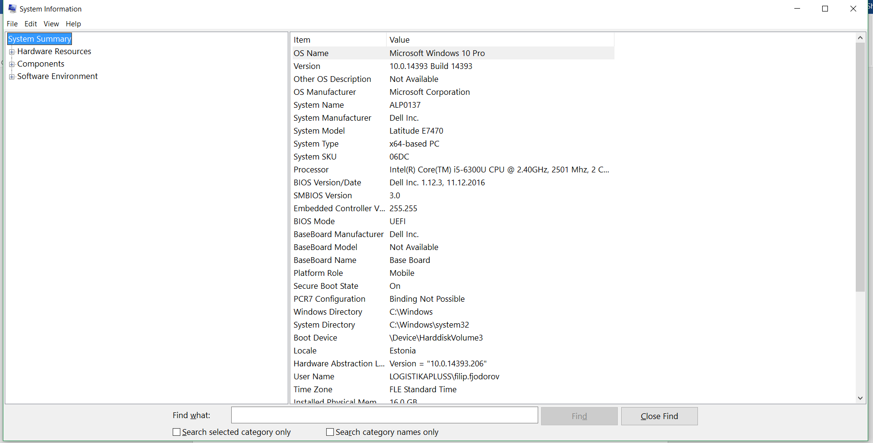

Pilt 3msinfo32.exe

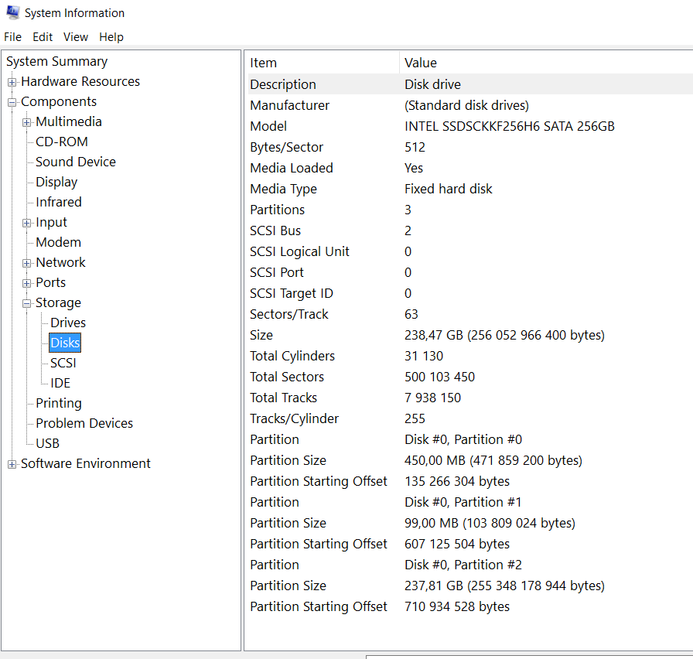

Pilt 4msinfo32 Disks

Lisaks selle on olemas erinevad tarkvarad, millega saab kätte saada vajalik riistvara info, nt Hwinfo, Aida, CPU-Z ja ne.

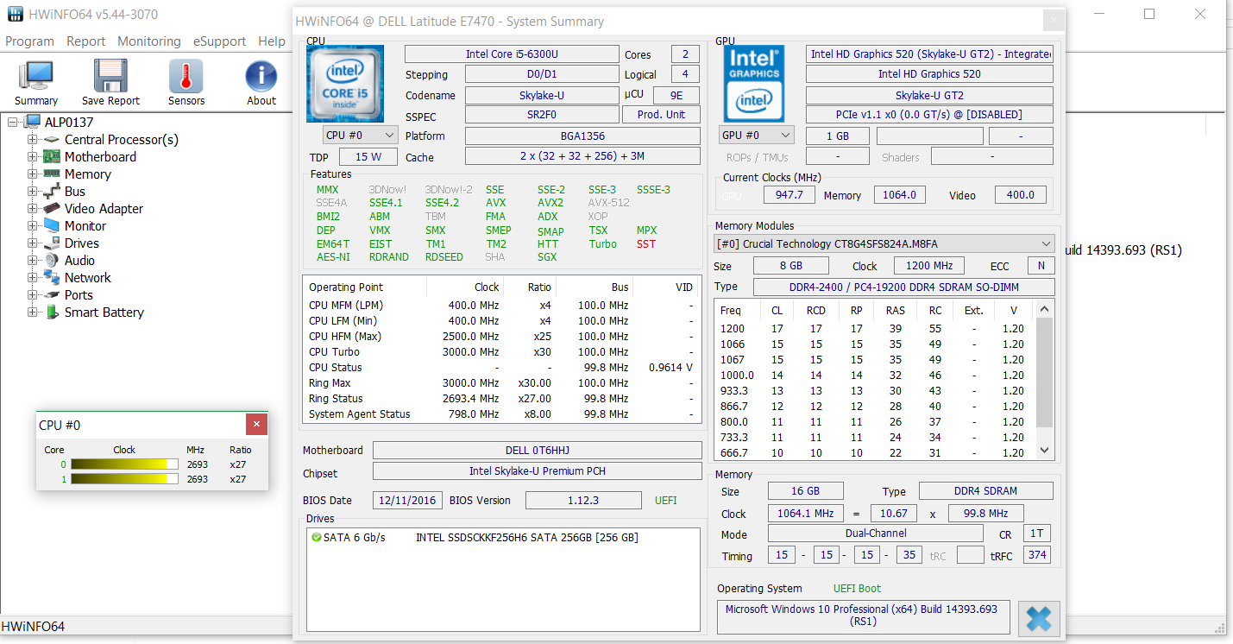

Pilt 5 Hwinfo

**Virtualbox**

student@ubuntusrv:~$ lsb_release -a

No LSB modules are available.

Distributor ID: Ubuntu

Description: Ubuntu 16.04.2 LTS

Release: 16.04

Codename: xenial

student@ubuntusrv:~$ uname -sr

Linux 4.4.0-64-generic

student@ubuntusrv:~$ inxi -r

Repos: Active apt sources in file: /etc/apt/sources.list

deb http://us.archive.ubuntu.com/ubuntu/ xenial main restricted

deb http://us.archive.ubuntu.com/ubuntu/ xenial-updates main restricted

deb http://us.archive.ubuntu.com/ubuntu/ xenial universe

deb http://us.archive.ubuntu.com/ubuntu/ xenial-updates universe

deb http://us.archive.ubuntu.com/ubuntu/ xenial multiverse

deb http://us.archive.ubuntu.com/ubuntu/ xenial-updates multiverse

deb http://us.archive.ubuntu.com/ubuntu/ xenial-backports main restricted universe multiverse

deb http://security.ubuntu.com/ubuntu xenial-security main restricted

deb http://security.ubuntu.com/ubuntu xenial-security universe

deb http://security.ubuntu.com/ubuntu xenial-security multiverse

student@ubuntusrv:~$ inxi -xxM

Machine: System: innotek (portable) product: VirtualBox v: 1.2 Chassis: Oracle type: 1

Mobo: Oracle model: VirtualBox v: 1.2

Bios: innotek v: VirtualBox date: 12/01/2006

student@ubuntusrv:~$ inxi -xxxS

System: Host: ubuntusrv Kernel: 4.4.0-64-generic x86_64 (64 bit gcc: 5.4.0)

Console: tty 0 Distro: Ubuntu 16.04 xenial

student@ubuntusrv:~$ inxi -s

Sensors: None detected - is lm-sensors installed and configured?

student@ubuntusrv:~$ cat /proc/cpuinfo

processor : 0

vendor_id : GenuineIntel

cpu family : 6

model : 78

model name : Intel(R) Core(TM) i5-6300U CPU @ 2.40GHz

stepping : 3

cpu MHz : 2495.996

cache size : 3072 KB

physical id : 0

siblings : 1

core id : 0

cpu cores : 1

apicid : 0

initial apicid : 0

fpu : yes

fpu_exception : yes

cpuid level : 22

wp : yes

flags : fpu vme de pse tsc msr pae mce cx8 apic sep mtrr pge mca cmov pat pse36 clflush mmx fxsr sse sse2 syscall nx rdtscp lm constant_tsc rep_good nopl xtopology nonstop_tsc pni pclmulqdq monitor ssse3 cx16 sse4_1 sse4_2 x2apic movbe popcnt aes xsave avx rdrand hypervisor lahf_lm abm 3dnowprefetch rdseed clflushopt

bugs :

bogomips : 4991.99

clflush size : 64

cache_alignment : 64

address sizes : 39 bits physical, 48 bits virtual

power management:

student@ubuntusrv:~$ inxi -C

CPU: Single core Intel Core i5-6300U (-UP-) cache: 3072 KB speed: 2495 MHz (max)

student@ubuntusrv:~$ inxi -xxC

CPU: Single core Intel Core i5-6300U (-UP-) cache: 3072 KB

flags: (lm nx sse sse2 sse3 sse4_1 sse4_2 ssse3) bmips: 4991 speed: 2495 MHz (max)

student@ubuntusrv:~$ inxi -t c

Processes: CPU: % used - top 5 active

1: cpu: 0.3% command: init pid: 1

2: cpu: 0.0% daemon: ~kworker/0:0~ pid: 10605

3: cpu: 0.0% daemon: ~kworker/u2:2~ pid: 8984

4: cpu: 0.0% daemon: ~jfsSync~ pid: 8800

5: cpu: 0.0% daemon: ~jfsCommit~ pid: 8799

student@ubuntusrv:~$ inxi -t cm

Processes: CPU: % used - top 5 active

1: cpu: 0.3% command: init pid: 1

2: cpu: 0.0% daemon: ~kworker/0:0~ pid: 10605

3: cpu: 0.0% daemon: ~kworker/u2:2~ pid: 8984

4: cpu: 0.0% daemon: ~jfsSync~ pid: 8800

5: cpu: 0.0% daemon: ~jfsCommit~ pid: 8799

Memory: MB / % used - Used/Total: 120.9/2000.3MB - top 5 active

1: mem: 20.59MB (1.0%) command: snapd pid: 996

2: mem: 6.71MB (0.3%) command: sshd: pid: 1340

3: mem: 6.19MB (0.3%) command: accounts-daemon pid: 992

4: mem: 5.89MB (0.2%) command: init pid: 1

5: mem: 5.85MB (0.2%) command: polkitd pid: 1027

student@ubuntusrv:~$ cat /proc/meminfo

MemTotal: 2048312 kB

MemFree: 1140080 kB

MemAvailable: 1815764 kB

Buffers: 36852 kB

Cached: 754000 kB

SwapCached: 0 kB

Active: 341720 kB

Inactive: 475984 kB

Active(anon): 29868 kB

Inactive(anon): 2776 kB

Active(file): 311852 kB

Inactive(file): 473208 kB

Unevictable: 3656 kB

Mlocked: 3656 kB

SwapTotal: 2097148 kB

SwapFree: 2097148 kB

Dirty: 24 kB

Writeback: 0 kB

AnonPages: 30556 kB

Mapped: 30528 kB

Shmem: 3368 kB

Slab: 58136 kB

SReclaimable: 44584 kB

SUnreclaim: 13552 kB

KernelStack: 2176 kB

PageTables: 2540 kB

NFS_Unstable: 0 kB

Bounce: 0 kB

WritebackTmp: 0 kB

CommitLimit: 3121304 kB

Committed_AS: 200176 kB

VmallocTotal: 34359738367 kB

VmallocUsed: 0 kB

VmallocChunk: 0 kB

HardwareCorrupted: 0 kB

AnonHugePages: 4096 kB

CmaTotal: 0 kB

CmaFree: 0 kB

HugePages_Total: 0

HugePages_Free: 0

HugePages_Rsvd: 0

HugePages_Surp: 0

Hugepagesize: 2048 kB

DirectMap4k: 59328 kB

DirectMap2M: 2037760 kB

student@ubuntusrv:~$ inxi -t m

Processes: Memory: MB / % used - Used/Total: 120.9/2000.3MB - top 5 active

1: mem: 20.59MB (1.0%) command: snapd pid: 996

2: mem: 6.71MB (0.3%) command: sshd: pid: 1340

3: mem: 6.19MB (0.3%) command: accounts-daemon pid: 992

4: mem: 5.89MB (0.2%) command: init pid: 1

5: mem: 5.85MB (0.2%) command: polkitd pid: 1027

student@ubuntusrv:~$ sudo dmidecode -t memory

# dmidecode 3.0

Getting SMBIOS data from sysfs.

SMBIOS 2.5 present.

student@ubuntusrv:~$ udo lshw -class memory

The program 'udo' is currently not installed. You can install it by typing:

sudo apt install udo

student@ubuntusrv:~$ sudo lshw -class memory

*-firmware

description: BIOS

vendor: innotek GmbH

physical id: 0

version: VirtualBox

date: 12/01/2006

size: 128KiB

capabilities: isa pci cdboot bootselect int9keyboard int10video acpi

*-memory

description: System memory

physical id: 1

size: 2000MiB

student@ubuntusrv:~$ free -h

total used free shared buff/cache available

Mem: 2.0G 57M 1.1G 3.3M 830M 1.7G

Swap: 2.0G 0B 2.0G

student@ubuntusrv:~$ lspci -tvnn

-[0000:00]-+-00.0 Intel Corporation 440FX - 82441FX PMC [Natoma] [8086:1237]

+-01.0 Intel Corporation 82371SB PIIX3 ISA [Natoma/Triton II] [8086:7000]

+-01.1 Intel Corporation 82371AB/EB/MB PIIX4 IDE [8086:7111]

+-02.0 InnoTek Systemberatung GmbH VirtualBox Graphics Adapter [80ee:beef]

+-03.0 Intel Corporation 82540EM Gigabit Ethernet Controller [8086:100e]

+-04.0 InnoTek Systemberatung GmbH VirtualBox Guest Service [80ee:cafe]

+-05.0 Intel Corporation 82801AA AC'97 Audio Controller [8086:2415]

+-06.0 Apple Inc. KeyLargo/Intrepid USB [106b:003f]

+-07.0 Intel Corporation 82371AB/EB/MB PIIX4 ACPI [8086:7113]

+-0b.0 Intel Corporation 82801FB/FBM/FR/FW/FRW (ICH6 Family) USB2 EHCI Controller [8086:265c]

\-0d.0 Intel Corporation 82801HM/HEM (ICH8M/ICH8M-E) SATA Controller [AHCI mode] [8086:2829]

student@ubuntusrv:~$ lsusb

Bus 001 Device 001: ID 1d6b:0002 Linux Foundation 2.0 root hub

Bus 002 Device 002: ID 80ee:0021 VirtualBox USB Tablet

Bus 002 Device 001: ID 1d6b:0001 Linux Foundation 1.1 root hub

student@ubuntusrv:~$ lsusb -t

/: Bus 02.Port 1: Dev 1, Class=root_hub, Driver=ohci-pci/12p, 12M

|__ Port 1: Dev 2, If 0, Class=Human Interface Device, Driver=usbhid, 12M

/: Bus 01.Port 1: Dev 1, Class=root_hub, Driver=ehci-pci/12p, 480M

student@ubuntusrv:~$ sudo fdisk -l

Disk /dev/ram0: 64 MiB, 67108864 bytes, 131072 sectors

Units: sectors of 1 * 512 = 512 bytes

Sector size (logical/physical): 512 bytes / 4096 bytes

I/O size (minimum/optimal): 4096 bytes / 4096 bytes

Disk /dev/ram1: 64 MiB, 67108864 bytes, 131072 sectors

Units: sectors of 1 * 512 = 512 bytes

Sector size (logical/physical): 512 bytes / 4096 bytes

I/O size (minimum/optimal): 4096 bytes / 4096 bytes

Disk /dev/ram2: 64 MiB, 67108864 bytes, 131072 sectors

Units: sectors of 1 * 512 = 512 bytes

Sector size (logical/physical): 512 bytes / 4096 bytes

I/O size (minimum/optimal): 4096 bytes / 4096 bytes

Disk /dev/ram3: 64 MiB, 67108864 bytes, 131072 sectors

Units: sectors of 1 * 512 = 512 bytes

Sector size (logical/physical): 512 bytes / 4096 bytes

I/O size (minimum/optimal): 4096 bytes / 4096 bytes

Disk /dev/ram4: 64 MiB, 67108864 bytes, 131072 sectors

Units: sectors of 1 * 512 = 512 bytes

Sector size (logical/physical): 512 bytes / 4096 bytes

I/O size (minimum/optimal): 4096 bytes / 4096 bytes

Disk /dev/ram5: 64 MiB, 67108864 bytes, 131072 sectors

Units: sectors of 1 * 512 = 512 bytes

Sector size (logical/physical): 512 bytes / 4096 bytes

I/O size (minimum/optimal): 4096 bytes / 4096 bytes

Disk /dev/ram6: 64 MiB, 67108864 bytes, 131072 sectors

Units: sectors of 1 * 512 = 512 bytes

Sector size (logical/physical): 512 bytes / 4096 bytes

I/O size (minimum/optimal): 4096 bytes / 4096 bytes

Disk /dev/ram7: 64 MiB, 67108864 bytes, 131072 sectors

Units: sectors of 1 * 512 = 512 bytes

Sector size (logical/physical): 512 bytes / 4096 bytes

I/O size (minimum/optimal): 4096 bytes / 4096 bytes

Disk /dev/ram8: 64 MiB, 67108864 bytes, 131072 sectors

Units: sectors of 1 * 512 = 512 bytes

Sector size (logical/physical): 512 bytes / 4096 bytes

I/O size (minimum/optimal): 4096 bytes / 4096 bytes

Disk /dev/ram9: 64 MiB, 67108864 bytes, 131072 sectors

Units: sectors of 1 * 512 = 512 bytes

Sector size (logical/physical): 512 bytes / 4096 bytes

I/O size (minimum/optimal): 4096 bytes / 4096 bytes

Disk /dev/ram10: 64 MiB, 67108864 bytes, 131072 sectors

Units: sectors of 1 * 512 = 512 bytes

Sector size (logical/physical): 512 bytes / 4096 bytes

I/O size (minimum/optimal): 4096 bytes / 4096 bytes

Disk /dev/ram11: 64 MiB, 67108864 bytes, 131072 sectors

Units: sectors of 1 * 512 = 512 bytes

Sector size (logical/physical): 512 bytes / 4096 bytes

I/O size (minimum/optimal): 4096 bytes / 4096 bytes

Disk /dev/ram12: 64 MiB, 67108864 bytes, 131072 sectors

Units: sectors of 1 * 512 = 512 bytes

Sector size (logical/physical): 512 bytes / 4096 bytes

I/O size (minimum/optimal): 4096 bytes / 4096 bytes

Disk /dev/ram13: 64 MiB, 67108864 bytes, 131072 sectors

Units: sectors of 1 * 512 = 512 bytes

Sector size (logical/physical): 512 bytes / 4096 bytes

I/O size (minimum/optimal): 4096 bytes / 4096 bytes

Disk /dev/ram14: 64 MiB, 67108864 bytes, 131072 sectors

Units: sectors of 1 * 512 = 512 bytes

Sector size (logical/physical): 512 bytes / 4096 bytes

I/O size (minimum/optimal): 4096 bytes / 4096 bytes

Disk /dev/ram15: 64 MiB, 67108864 bytes, 131072 sectors

Units: sectors of 1 * 512 = 512 bytes

Sector size (logical/physical): 512 bytes / 4096 bytes

I/O size (minimum/optimal): 4096 bytes / 4096 bytes

Disk /dev/sda: 8 GiB, 8589934592 bytes, 16777216 sectors

Units: sectors of 1 * 512 = 512 bytes

Sector size (logical/physical): 512 bytes / 512 bytes

I/O size (minimum/optimal): 512 bytes / 512 bytes

Disklabel type: dos

Disk identifier: 0x88290ba2

Device Boot Start End Sectors Size Id Type

/dev/sda1 * 2048 999423 997376 487M 83 Linux

/dev/sda2 1001470 16775167 15773698 7.5G 5 Extended

/dev/sda5 1001472 16775167 15773696 7.5G 8e Linux LVM

Disk /dev/mapper/ubuntusrv--vg-root: 5.5 GiB, 5926551552 bytes, 11575296 sectors

Units: sectors of 1 * 512 = 512 bytes

Sector size (logical/physical): 512 bytes / 512 bytes

I/O size (minimum/optimal): 512 bytes / 512 bytes

Disk /dev/mapper/ubuntusrv--vg-swap_1: 2 GiB, 2147483648 bytes, 4194304 sectors

Units: sectors of 1 * 512 = 512 bytes

Sector size (logical/physical): 512 bytes / 512 bytes

I/O size (minimum/optimal): 512 bytes / 512 bytes

student@ubuntusrv:~$ lsblk -f

NAME FSTYPE LABEL UUID MOUNTPOINT

sda

├─sda1 ext2 70f854b4-d44a-464e-a9dc-d910f0dbc19d /boot

├─sda2

└─sda5 LVM2_member mmERZ1-amVN-JwSU-WfNE-knhY-YTjc-iuOPig

├─ubuntusrv--vg-root ext4 3ff60ee0-de5c-4a2c-bd23-8eab5a3fb038 /

└─ubuntusrv--vg-swap_1

swap 47acf472-50e6-4b8e-97d3-018397a15e9a [SWAP]

sr0

sr1

student@ubuntusrv:~$ findmnt -D

SOURCE FSTYPE SIZE USED AVAIL USE% TARGET

udev devtmpfs 980.6M 0 980.6M 0% /dev

tmpfs tmpfs 200M 3.3M 196.8M 2% /run

/dev/mapper/ubuntusrv--vg-root ext4 5.3G 1.9G 3.1G 35% /

tmpfs tmpfs 1000.2M 0 1000.2M 0% /dev/shm

tmpfs tmpfs 5M 0 5M 0% /run/lock

tmpfs tmpfs 1000.2M 0 1000.2M 0% /sys/fs/cgroup

/dev/sda1 ext2 471.6M 104.7M 342.6M 22% /boot

lxcfs fuse.lxcfs 0 0 0 - /var/lib/lxcfs

tmpfs tmpfs 200M 0 200M 0% /run/user/1000

student@ubuntusrv:~$ inxi -p

Partition: ID-1: / size: 5.4G used: 1.9G (38%) fs: ext4 dev: /dev/dm-0

ID-2: /boot size: 472M used: 105M (24%) fs: ext2 dev: /dev/sda1

ID-3: swap-1 size: 2.15GB used: 0.00GB (0%) fs: swap dev: /dev/dm-1

student@ubuntusrv:~$ sudo hdparm -I /dev/sda

/dev/sda:

ATA device, with non-removable media

Model Number: VBOX HARDDISK

Serial Number: VB7386bc31-0202a8a0

Firmware Revision: 1.0

Standards:

Used: ATA/ATAPI-6 published, ANSI INCITS 361-2002

Supported: 6 5 4

Configuration:

Logical max current

cylinders 16383 16383

heads 16 16

sectors/track 63 63

--

CHS current addressable sectors: 16514064

LBA user addressable sectors: 16777216

LBA48 user addressable sectors: 16777216

Logical/Physical Sector size: 512 bytes

device size with M = 1024*1024: 8192 MBytes

device size with M = 1000*1000: 8589 MBytes (8 GB)

cache/buffer size = 256 KBytes (type=DualPortCache)

Capabilities:

LBA, IORDY(cannot be disabled)

Queue depth: 32

Standby timer values: spec'd by Vendor, no device specific minimum

R/W multiple sector transfer: Max = 128 Current = 128

DMA: mdma0 mdma1 mdma2 udma0 udma1 udma2 udma3 udma4 udma5 *udma6

Cycle time: min=120ns recommended=120ns

PIO: pio0 pio1 pio2 pio3 pio4

Cycle time: no flow control=120ns IORDY flow control=120ns

Commands/features:

Enabled Supported:

* Power Management feature set

* Write cache

* Look-ahead

* 48-bit Address feature set

* Mandatory FLUSH_CACHE

* FLUSH_CACHE_EXT

* Gen2 signaling speed (3.0Gb/s)

* Native Command Queueing (NCQ)

Checksum: correct

student@ubuntusrv:~$ xrandr

Can't open display

student@ubuntusrv:~$ cat /proc/asound/cards

0 [I82801AAICH ]: ICH - Intel 82801AA-ICH

Intel 82801AA-ICH with AD1980 at irq 21

student@ubuntusrv:~$ inxi -xxA

Audio: Card Intel 82801AA AC'97 Audio Controller

driver: snd_intel8x0 ports: d100 d200 bus-ID: 00:05.0 chip-ID: 8086:2415

Sound: Advanced Linux Sound Architecture v: k4.4.0-64-generic

student@ubuntusrv:~$ dmidecode

# dmidecode 3.0

/sys/firmware/dmi/tables/smbios_entry_point: Permission denied

Scanning /dev/mem for entry point.

/dev/mem: Permission denied

student@ubuntusrv:~$ sudo dmidecode

# dmidecode 3.0

Getting SMBIOS data from sysfs.

SMBIOS 2.5 present.

10 structures occupying 450 bytes.

Table at 0x000E1000.

Handle 0x0000, DMI type 0, 20 bytes

BIOS Information

Vendor: innotek GmbH

Version: VirtualBox

Release Date: 12/01/2006

Address: 0xE0000

Runtime Size: 128 kB

ROM Size: 128 kB

Characteristics:

ISA is supported

PCI is supported

Boot from CD is supported

Selectable boot is supported

8042 keyboard services are supported (int 9h)

CGA/mono video services are supported (int 10h)

ACPI is supported

Handle 0x0001, DMI type 1, 27 bytes

System Information

Manufacturer: innotek GmbH

Product Name: VirtualBox

Version: 1.2

Serial Number: 0

UUID: C8007D85-CC23-447E-887D-78C52DE2B180

Wake-up Type: Power Switch

SKU Number: Not Specified

Family: Virtual Machine

Handle 0x0008, DMI type 2, 15 bytes

Base Board Information

Manufacturer: Oracle Corporation

Product Name: VirtualBox

Version: 1.2

Serial Number: 0

Asset Tag: Not Specified

Features:

Board is a hosting board

Location In Chassis: Not Specified

Chassis Handle: 0x0003

Type: Motherboard

Contained Object Handles: 0

Handle 0x0003, DMI type 3, 13 bytes

Chassis Information

Manufacturer: Oracle Corporation

Type: Other

Lock: Not Present

Version: Not Specified

Serial Number: Not Specified

Asset Tag: Not Specified

Boot-up State: Safe

Power Supply State: Safe

Thermal State: Safe

Security Status: None

Handle 0x0007, DMI type 126, 42 bytes

Inactive

Handle 0x0005, DMI type 126, 15 bytes

Inactive

Handle 0x0006, DMI type 126, 28 bytes

Inactive

Handle 0x0002, DMI type 11, 7 bytes

OEM Strings

String 1: vboxVer_5.1.14

String 2: vboxRev_112924

Handle 0x0008, DMI type 128, 8 bytes

OEM-specific Type

Header and Data:

80 08 08 00 FC 15 26 00

Handle 0xFEFF, DMI type 127, 4 bytes

End Of Table

student@ubuntusrv:~$ ifconfig -a

enp0s3 Link encap:Ethernet HWaddr 08:00:27:1b:90:93

inet addr:192.168.1.3 Bcast:192.168.1.255 Mask:255.255.255.0

inet6 addr: fe80::a00:27ff:fe1b:9093/64 Scope:Link

UP BROADCAST RUNNING MULTICAST MTU:1500 Metric:1

RX packets:21986 errors:0 dropped:0 overruns:0 frame:0

TX packets:11648 errors:0 dropped:0 overruns:0 carrier:0

collisions:0 txqueuelen:1000

RX bytes:27647200 (27.6 MB) TX bytes:1017567 (1.0 MB)

lo Link encap:Local Loopback

inet addr:127.0.0.1 Mask:255.0.0.0

inet6 addr: ::1/128 Scope:Host

UP LOOPBACK RUNNING MTU:65536 Metric:1

RX packets:160 errors:0 dropped:0 overruns:0 frame:0

TX packets:160 errors:0 dropped:0 overruns:0 carrier:0

collisions:0 txqueuelen:1

RX bytes:11840 (11.8 KB) TX bytes:11840 (11.8 KB)

student@ubuntusrv:~$ ip addr list

1: lo: <LOOPBACK,UP,LOWER_UP> mtu 65536 qdisc noqueue state UNKNOWN group default qlen 1

link/loopback 00:00:00:00:00:00 brd 00:00:00:00:00:00

inet 127.0.0.1/8 scope host lo

valid_lft forever preferred_lft forever

inet6 ::1/128 scope host

valid_lft forever preferred_lft forever

2: enp0s3: <BROADCAST,MULTICAST,UP,LOWER_UP> mtu 1500 qdisc pfifo_fast state UP group default qlen 1000

link/ether 08:00:27:1b:90:93 brd ff:ff:ff:ff:ff:ff

inet 192.168.1.3/24 brd 192.168.1.255 scope global enp0s3

valid_lft forever preferred_lft forever

inet6 fe80::a00:27ff:fe1b:9093/64 scope link

valid_lft forever preferred_lft forever

student@ubuntusrv:~$ inxi -xi

Network: Card: Intel 82540EM Gigabit Ethernet Controller

driver: e1000 v: 7.3.21-k8-NAPI port: d010 bus-ID: 00:03.0

IF: enp0s3 state: up speed: 1000 Mbps duplex: full mac: 08:00:27:1b:90:93

WAN IP: 217.71.44.106

IF: enp0s3 ip-v4: 192.168.1.3 ip-v6: fe80::a00:27ff:fe1b:9093

student@ubuntusrv:~$ inxi -xxN

Network: Card: Intel 82540EM Gigabit Ethernet Controller

driver: e1000 v: 7.3.21-k8-NAPI port: d010 bus-ID: 00:03.0 chip-ID: 8086:100e

student@ubuntusrv:~$ inxi -xn

Network: Card: Intel 82540EM Gigabit Ethernet Controller

driver: e1000 v: 7.3.21-k8-NAPI port: d010 bus-ID: 00:03.0

IF: enp0s3 state: up speed: 1000 Mbps duplex: full mac: 08:00:27:1b:90:93

student@ubuntusrv:~$ iwconfig

The program 'iwconfig' is currently not installed. You can install it by typing:

sudo apt install wireless-tools

student@ubuntusrv:~$ hcitool dev Bluetooth

The program 'hcitool' is currently not installed. You can install it by typing:

sudo apt install bluez

student@ubuntusrv:~$ glxinfo -B

Error: unable to open display

student@ubuntusrv:~$ glxinfo | grep -i opengl

Error: unable to open display

student@ubuntusrv:~$ inxi -xG

Graphics: Card: InnoTek Systemberatung VirtualBox Graphics Adapter bus-ID: 00:02.0

Display Server: N/A driver: N/A tty size: 90x26 Advanced Data: N/A out of X

student@ubuntusrv:~$ lspci -vnn | grep VGA -A 12

00:02.0 VGA compatible controller [0300]: InnoTek Systemberatung GmbH VirtualBox Graphics Adapter [80ee:beef] (prog-if 00 [VGA controller])

Flags: bus master, fast devsel, latency 0, IRQ 18

Memory at e0000000 (32-bit, prefetchable) [size=16M]

Expansion ROM at <unassigned> [disabled]

Kernel driver in use: vboxvideo

Kernel modules: vboxvideo

00:03.0 Ethernet controller [0200]: Intel Corporation 82540EM Gigabit Ethernet Controller [8086:100e] (rev 02)

Subsystem: Intel Corporation PRO/1000 MT Desktop Adapter [8086:001e]

Flags: bus master, 66MHz, medium devsel, latency 64, IRQ 19

Memory at f0000000 (32-bit, non-prefetchable) [size=128K]

I/O ports at d010 [size=8]

Capabilities: <access denied>

student@ubuntusrv:~$ sudo lshw -numeric -C

Hardware Lister (lshw) - B.02.17

usage: lshw [-format] [-options ...]

lshw -version

-version print program version (B.02.17)

format can be

-html output hardware tree as HTML

-xml output hardware tree as XML

-short output hardware paths

-businfo output bus information

options can be

-class CLASS only show a certain class of hardware

-C CLASS same as '-class CLASS'

-c CLASS same as '-class CLASS'

-disable TEST disable a test (like pci, isapnp, cpuid, etc. )

-enable TEST enable a test (like pci, isapnp, cpuid, etc. )

-quiet don't display status

-sanitize sanitize output (remove sensitive information like serial numbers, etc.)

-numeric output numeric IDs (for PCI, USB, etc.)

student@ubuntusrv:~$ inxi -G

Graphics: Card: InnoTek Systemberatung VirtualBox Graphics Adapter

Display Server: N/A driver: N/A tty size: 90x26 Advanced Data: N/A out of X

student@ubuntusrv:~$